Create an New Customer

# Definitions

* **Freedom SOS CRM**: This is the site that tracks all leads and clients. The site is located at <http://dealers.freedomsos.com>.
* **System**: This refers to the **Freedom SOS CRM** website.
* **Lead**: This is a person that has shown interest in our products and services.
* **Customer**: This is a person that has purchased on of our products and services.
* **Monitored Party**: This is a person who wears the monitored device and for whom Freedom SOS is responsible to monitor.

# Description

This manual will describe how a user **Freedom SOS CRM** can create a new customer in the system.

# Assumptions

For this user manual to work below is a list of assumptions the manual makes:

* Valid credentials to the **Freedom SOS CRM**. The user should be able to authenticate. En order to do this the user should have the following three items:
  + Dealer ID
  + Username
  + Password

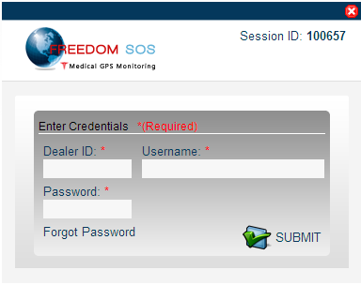

If you have forgotten your credentials to the site please contact the administrator via email. Please use the email address that you registered as a dealer.

# Steps

In order to understand how things work. It must be understood that before a new customer can be created, the user must create a lead in the **System** first.

## Create a Lead

There are two ways to create a lead. The first is by clicking on the New Lead from the main menu under leads. The second is from the plus sign on the tabs. See image below, the areas are circled in red.

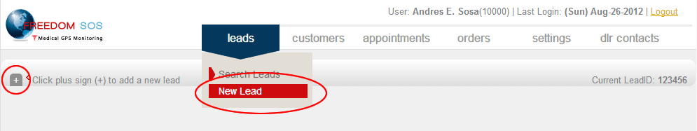

### Source and Disposition

Select the source of the lead and what is the leads disposition.

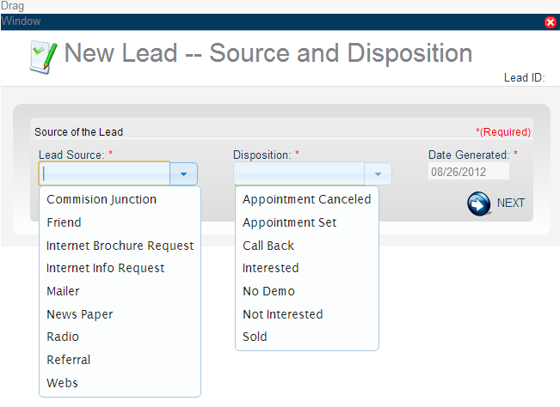

Please note that the fields marked with the red asterisk (**\***) are required.

### Personal Information

This section is asking for the information on the person that is interested in the system. It is preferred that the name of the person that will wear the device.

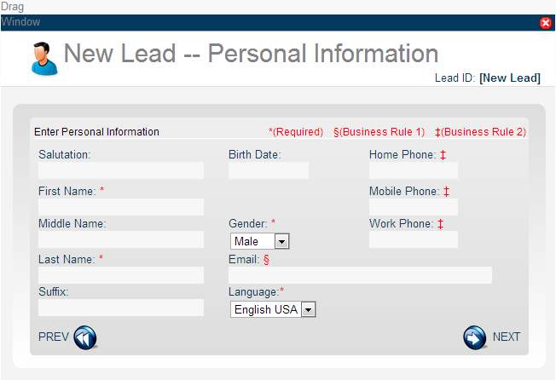

Please note the Business Rule 1 and Business Rule 2.

#### Business Rule 1

This rule says that in order for the system to send email notifications in the event of an emergency an email is required; preferably the email of the **Monitored Party**.

#### Business Rule 2

In order to be able to contact the **Monitored Party** in the event of an emergency, and as a secondary backup it is required that one of the three phone fields are filled.

### Premise Address

This is the address in which the **Monitored Party** resides. This is the preferred address; however, if the Monitored Party resides in a convalescent home then the address could be the convalescent home or a responsible party’s home or PO Box.

Please be sure to enter the correct time zone that the Monitored Party is residing in. This is critical so accurate monitored event times can be calculated and reported.

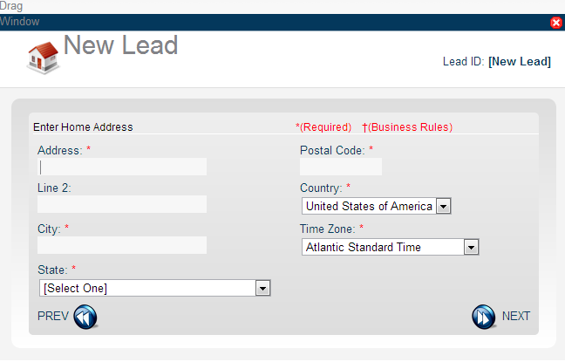

### Products

This step tells us what product the lead was offered. At the moment there is only one product that is offered. There will be more to come.

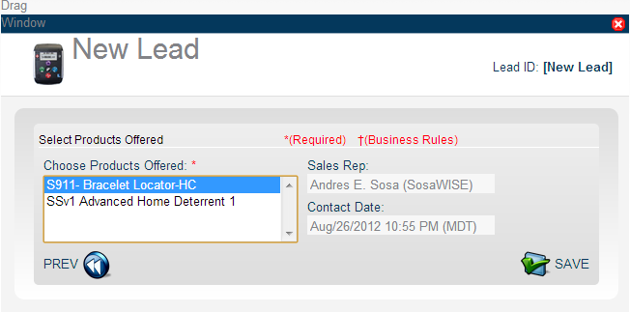

Once you click on the Save button the lead process for creating a lead is initiated. After a few seconds the lead record is created and opened in the main pain. A message appears and shows the Lead ID created for this record. See image below.

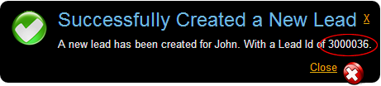

Behind the message is the Lead card with all the information that was just entered. Also the account is noted with newly created lead.

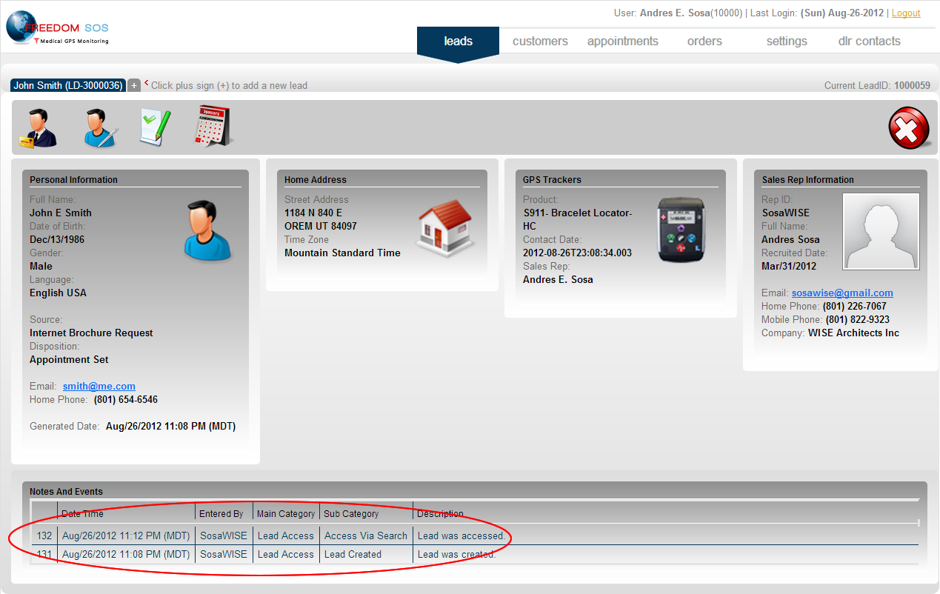

## Create the Customer

Once the lead is created the next step is to convert the lead into a customer. In order to convert leads into a customer please follow the steps listed below:

### Search the Lead

Go to the Leads search page. To do this go to the leads main menu and select the Search Leads submenu.

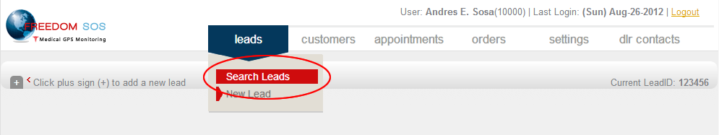

Enter any one of the fields to filter the result.

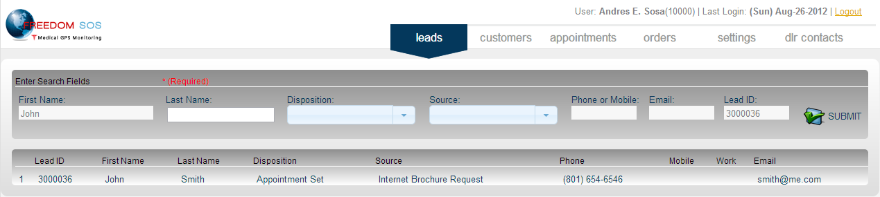

Select the line that represents the lead that you want by clicking on it. Notice that if you place the mouse over the row it will turn yellow.

### Click on the Purchase Button

Once the lead card is open, click on the Purchase button.



The conversion process begins.

### Select Product

Select the product the new customer wants.

